Financial results of cultural institutions in the first quarter of 2022
In the first quarter of 2022, the financial results of cultural institutions increased compared to those obtained in the corresponding period of the previous year. Total revenues increased by 19.7% during this period. Investment outlays increased by 21.3%.
19.7%
Total revenue increase y / y
Total revenues of cultural institutions in the first quarter of 2022 were 19.7% higher than revenues generated in the previous year and amounted to 2,668.3 million PLN. The structure of the revenues was composed of: net revenues from sales of products, goods and materials (93.3%), other operating revenues (6.6%) and financial revenues (0.1%). More than 24% of the total revenues were generated by cultural institutions from Mazowieckie Voivodship.
On average, the total revenues per 1 cultural institution amounted to PLN 568.3 thousand PLN. The highest total revenues per 1 unit were achieved by cultural institutions in Mazowieckie Voivodeship - 1,024.8 thous. PLN, while the lowest in Lubelskie Voivodeship - 286.1 thousand PLN.
Total costs during the period considered were 21.8% higher than in the previous year and amounted to 2,464.1 million PLN. The structure of these costs was composed of: operating costs (99.3%), other operating costs (0.6 %), financial costs (0.1%). More than 24% of the total costs were incurred by cultural institutions from Mazowieckie Voivodship.
Total revenues of gminas local cultural institutions in the first quarter of 2022 amounted to 1,563.7 million PLN
National cultural institutions achieved in the first quarter of 2022 total revenues of PLN 465.9 million, while total revenues of local government cultural institutions amounted to PLN 2,202.4 million.

Table 1. Financial results of cultural institutions
Specification | 01-03. 2021 | 01-03. 2022 | 01-03. 2022=100
Specification | in million PLN |  | 01-03. 2022=100
Total revenues | 2,229.3 | 2,668.3 | 119.7
Total costs | 2,023.5 | 2,464.1 | 121.8
Gross financial result | 205,8 | 204.3 | 99.3
Net financial result | 205.5 | 204.0 | 99.3
Net profit | 268.5 | 275.7 | 102.7
Net loss | 63.0 | 71.7 | 113.7
Investment outlays | 168.5 | 204.4 | 121.3
Outlays on intangible fixed assets | 3.4 | 3.9 | 113.1
Gross financial result amounted to 204.3 million PLN (profit 275.8 million PLN, gross loss 71.5 million PLN). Net financial result amounted to 204.0 million PLN (205.5 million PLN in the previous year), with a simultaneous increase in net profit (by 2.7%) and an increase in net loss (by 13.7%).
Net financial result of cultural institution in the first quarter of 2022 amounted to 204.0 million PLN
In the first quarter of 2022 investment outlays of cultural institutions were 21.3% higher than in the previous year and amounted to 204.4 million PLN. The greatest share in investment outlays had cultural institutions in Mazowieckie Voivodship (24.3%).
Investment outlays incurred by local government cultural institutions amounted to 123.5 million PLN, i.e 60.4% of the total amount of investment outlays.

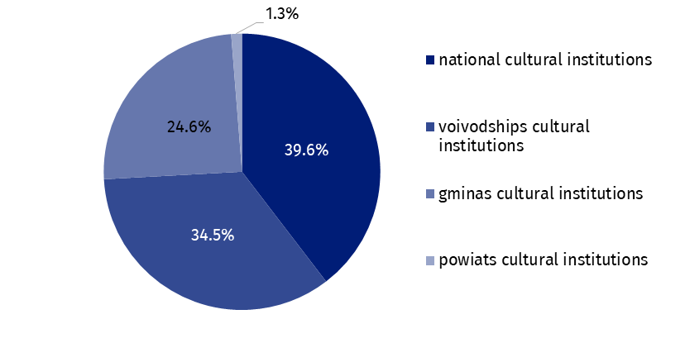
Chart 1. The structure of investment outlays of cultural institutions by legal forms in the first quarter of 2022
Outlays of cultural institutions on intangible and legal assets increased by 13.1% compared to the first quarter of 2021 and amounted to PLN 3.9 million. The largest outlays was incurred by cultural institutions from Mazowieckie Voivodship (69.8% of the total).

Table 2. Total revenues and total costs of cultural institutions by selected divisions and classes of PKD classification in the first quarter of 2022
Specification | Number of  cultural  institutions | Total  revenues | Total  costs
Specification | Number of  cultural  institutions | in million PLN
Grand total | 4,695 | 2,668.3 | 2,464.1
local government units property | 4,623 | 2,202.4 | 2,041.5
government property | 72 | 465.9 | 422.6
of which:
creative, arts and entertainment activities | 2,318 | 1,623.4 | 1,481.4
of which:
performing arts activities | 152 | 510.1 | 499.5

Table 2. Total revenues and total costs of cultural institutions by selected divisions and classes of PKD classification in the first quarter of 2022 (cont.)
Specification | Number of  cultural  institutions | Total  revenues | Total  costs
Specification | Number of  cultural  institutions | in million PLN
operation of arts facilities | 2,155 | 1,072.6 | 949.1
libraries, archives, museums and other cultural activities | 2,371 | 1,009.2 | 945.1
of which
library and archives activities | 1,978 | 473.5 | 435.2
museums activities | 385 | 523.0 | 496.9
The data presented in this study were prepared on the basis of the form with the symbol
F-01/dk Quarterly report on the finances of cultural institutions.
In the case of quoting data from the Statistics Poland, please provide information: "Statistics Poland data source", and in the case of publishing calculations made on data published by the Statistics Poland, please provide information: "Own study based on Statistics Poland data".

Prepared by:  Statistical Office in Kraków  Director Agnieszka Szlubowska  Phone: (+48 12) 420 40 50 | Issued by:  The Spokesperson for the President  of Statistics Poland  Karolina Banaszek  Phone: (+48) 695 255 011
Press Office  Phone: (+48 22) 608 38 04  e-mail: obslugaprasowa@stat.gov.pl |   stat.gov.pl/en/

@StatPoland

@GlownyUrzadStatystyczny

gus_stat

glownyurzadstatystycznygus

glownyurzadstatystyczny
Related information
Financial results of cultural institutions in the first quarter of 2021
Methodological report. Non-financial enterprises surveys 2019
Terms used inn official statistics
Total revenues
Total costs
Gross financial result
Net financial result
Investment outlays
Outlays on intangible fixed assets
Cultural institution

