Financial results of cultural institutions in the period January–June 2022
In the first half of 2022 financial results of cultural institutions were higher in comparison to results obtained in the corresponding period of the previous year. Total revenues increased by 23,2% during this period. Investment outlays increased by 24.5%.
23.2%
Total revenue increase y/y
Total revenues of cultural institutions in the first half of 2022 were higher by 23.2% than revenues generated in the previous year and amounted to PLN 5,769.8 million. In the structure of these revenues, 92.2% were net revenues from sales of products, goods and materials, 7.6% – other operating revenues and 0.2% – financial revenues. More than 25% of the total revenues accounted for the total revenues of cultural institutions from Mazowieckie Voivodship.
On average, total revenues per 1 cultural institution amounted to PLN 1,228.1 thousand. The highest total revenues per 1 unit were achieved by cultural institutions in Mazowieckie Voivodship – PLN 2,254.1 thousand, while the lowest in Lubelskie Voivodship – PLN 598.8 thousand.
Total costs during the period considered were higher by 25.5% than in the previous year and amounted to PLN 5,428.7 million. The structure of these costs was composed of: operating costs (98.8%), other operating costs (1.1 %), financial costs (0.1%). More than 24% of the total costs were incurred by units from Mazowieckie Voivodship.
National cultural institutions in the first half of 2022, achieved total revenues of PLN 1,051.3 million, while total revenues of local government units amounted to PLN 4,718.5 million.
Total revenues of gminas local cultural institutions in the first half of 2022 amounted to PLN 3,344.7 million

Table 1. Financial results of cultural institutions
Specification | 01–06 2021 | 01–06 2022 | 01–06 2021=100
Specification | in PLN millions |  | 01–06 2021=100
Total revenues | 4,682.3 | 5,769.8 | 123.2
Total costs | 4,324.8 | 5,428.7 | 125.5
Gross financial result | 357.5 | 341.1 | 95.4
Net financial result | 356.9 | 340.3 | 95.3
Net profit | 425.2 | 424.0 | 99.7
Net loss | 68.3 | 83.8 | 122.6
Investment outlays | 460.6 | 573.4 | 124.5
Outlays on intangible fixed assets | 9.3 | 9.8 | 104.9
Gross financial result amounted to PLN 341.1 million (profit PLN 424.6 million, loss PLN 83.5 million).
Net financial result of cultural institution in the first half of 2022 amounted to PLN 340.3 million
Net financial result amounted to PLN 340.3 million (compared to PLN 356.9 million in the previous year), with a decrease of net profit (by 0.3%) and increase of net loss (by 22.6%).
In the first half of 2022 the investment outlays of cultural institutions and were higher by 24.5% than in the previous year and amounted to PLN 573.4 million. Almost 27% of the total investment outlays were outlays of cultural institutions from Mazowieckie Voivodship.
Investment outlays incurred by local government cultural institutions amounted to PLN 361.6 million, i.e 63.1% of the total amount of investment outlays.

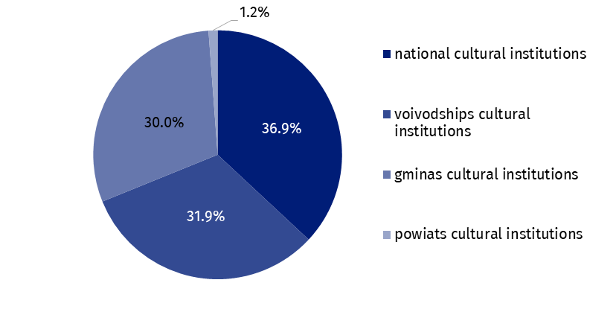
Chart 1. The structure of investment outlays of cultural institutions by legal forms in the first half of 2022
Outlays on intangible fixed assets increased in comparison to the first half of the 2021 by 4.9% and amounted to PLN 9.8 million. The largest expenditures were incurred by cultural institutions from Mazowieckie Voivodship (60.0% of the total).

Table 2. Total revenues and total costs of cultural institutions by selected divisions and classes of PKD classification in the first half of 2022
Specification | Number of cultural institutions | Total revenues | Total costs
Specification | Number of cultural institutions | in PLN millions
Grand total | 4,698 | 5,769.8 | 5,428.7
local government units property | 4,625 | 4,718.5 | 4,480.1
government property | 73 | 1,051.3 | 948.6
of which:
creative, arts and entertainment activities | 2,319 | 3,509.3 | 3,309.9
of which:
performing arts activities | 152 | 1,075.0 | 1,064.5

Table 2. Total revenues and total costs of cultural institutions by selected divisions and classes of PKD classification in the first quarter of 2022 (cont.)
Specification | Number of cultural institutions | Total revenues | Total costs
Specification | Number of cultural institutions | in PLN millions
operation of arts facilities | 2,156 | 2,348.9 | 2,165.9
libraries, archives, museums and other cultural activities | 2,373 | 2,180.7 | 2,039.6
of which
library and archives activities | 1,978 | 977.8 | 924.3
museums activities | 387 | 1,169.6 | 1,084.8
The data presented in this study were prepared on the basis of the form with the symbol F-01/dk Quarterly report on the finances of cultural institutions.
In the case of quoting data from the Statistics Poland, please provide information: "Statistics Poland data source", and in the case of publishing calculations made on data published by the Statistics Poland, please provide information: "Own study based on Statistics Poland data".

Prepared by:  Statistical Office in Kraków  Director Agnieszka Szlubowska  Phone: (+48 12) 420 40 50 | Issued by:  The Spokesperson for the President  of Statistics Poland  Karolina Banaszek  Phone: (+48) 695 255 011
Press Office  Phone: (+48 22) 608 38 04  e-mail: obslugaprasowa@stat.gov.pl |   stat.gov.pl/en/

@StatPoland

@GlownyUrzadStatystyczny

gus_stat

glownyurzadstatystycznygus

glownyurzadstatystyczny
Related information
Financial results of cultural institutions in the first quarter of 2022
Methodological report. Non-financial enterprises surveys 2019
Terms used inn official statistics
Total revenues
Total costs
Gross financial result
Net financial result
Investment outlays
Outlays on intangible fixed assets
Cultural institution

