Financial results of cultural institutions in 2022 – preliminary data
In 2022, the financial results of cultural institutions increased compared to the previous year. Total revenues increased by 18.1% and investment outlays by 25.1%.
18.1%
Total revenue increase y/y
Total revenues cultural institutions in 2022 amounted to PLN 12,394.1 million. In the structure of revenues, 90.8% were net revenues from sale of products, goods and materials, 9.0% – other operating revenues and 0.2% – financial revenues. More than 26.0% of revenues were the total revenues of cultural institutions from Mazowieckie Voivodship.
Total revenues of gminas local cultural institutions in 2022 amounted to PLN 6,990.5 million
Average total revenue per 1 cultural institution amounted to PLN 2,629.8 thousand. Analysing the phenomenon in individual voivodships, we observe that the highest revenues per 1 institution were achieved by cultural institutions in Mazowieckie Voivodship – PLN 4,976.5 thousand, while the lowest in Lubelskie Voivodship – PLN 1,231.3 thousand.
National cultural institutions, achieved total revenues of PLN 2,491.6 million, while revenues of local government units amounted to PLN 9,902.5 million.
In the total revenue of cultural institutions, the largest share was held by entities operating arts facilities – 40.6%, followed by institutions operating museums – 21.1%, activities related to performing arts – 18.2% and the activities of libraries and archives – 16.5%.
Total costs during the period considered were higher by 18.2% than in the previous year and amounted to PLN 12,274.9 million. The structure of costs was composed of: operating costs (98.2%), other operating costs (1.7%), financial costs (0.1%). More than 26.0% of the total costs were the costs of cultural institutions from Mazowieckie Voivodship.
In the total costs of cultural institutions, the largest share was held by entities operating arts facilities – 40.7%, followed by institutions operating museums – 20.6%, activities related to performing arts – 18.4% and activities of libraries and archives – 16.7%

Table 1. Financial results of cultural institutions
Specification | 01–12. 2021 | 01–12. 2022 | 01–12. 2021=100
Specification | in PLN millions |  | 01–12. 2021=100
Total revenues | 10,494.8 | 12,394.1 | 118.1
Total costs | 10,385.8 | 12,274.9 | 118.2
Gross financial result | 109.0 | 119.2 | 109.4
Net financial result | 107.6 | 117.3 | 109.0
Net profit | 210.3 | 251.7 | 119.7
Net loss | 102.7 | 134.4 | 130.9
Investment outlays | 1,536.1 | 1,921.9 | 125.1
Outlays on intangible fixed assets | 53.7 | 33.6 | 62.7
Gross financial result amounted to PLN 119.2 million (gross profit PLN 253.3 million, gross loss PLN 134.1 million). Net financial result amounted to PLN 117.3 million (PLN 107.6 million in the previous year), with a simultaneous increase in net profit (by 19.7%) and increase in net loss (by 30.9%).
Net financial result of cultural institution in 2022 amounted to PLN 117.3 million
In 2022 the investment outlays of cultural institutions were higher by 25.1% than in the previous year and amounted to PLN 1,921.9 million. Almost 30.0% share in investment outlays had cultural institutions in Mazowieckie Voivodship.
Investment outlays incurred by local government cultural institutions amounted to PLN 1,115.1 million, i.e. 58.0% of the total amount of investment outlays.

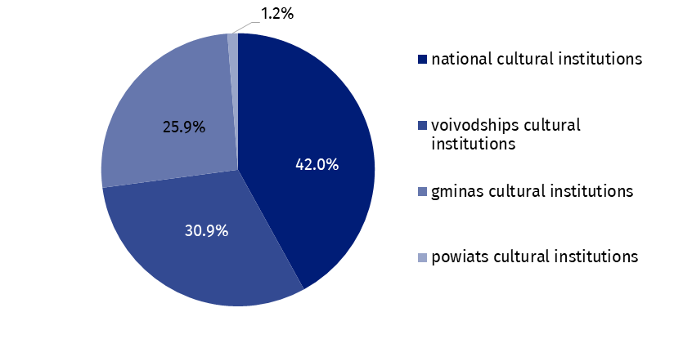
Chart 1. The structure of investment outlays of cultural institutions by legal forms in 2022
Outlays incurred by cultural institutions on intangible assets decreased compared to the corresponding period of the previous year by 37.3% and amounted to PLN 33.6 million. Over 54% of expenditures on intangible assets were expenditures on intangible assets of cultural institutions from Mazowieckie Voivodship.

Table 2. Total revenues and total costs of cultural institutions by selected divisions and classes of PKD classification in 2022
Specification | Number of cultural institutions | Total revenues | Total costs
Specification | Number of cultural institutions | in PLN millions
Grand total | 4,713 | 12,394.1 | 12,274.9
local government units property | 4,639 | 9,902.5 | 9,860.9
government property | 74 | 2,491.6 | 2,414.0
of which:
creative, arts and entertainment activities | 2,331 | 7,452.6 | 7,438.0
of which:
performing arts activities | 152 | 2,252.9 | 2,259.2
operation of arts facilities | 2,168 | 5,027.2 | 4,995.5
libraries, archives, museums and other cultural activities | 2,376 | 4,747.1 | 4,646.6
of which
library and archives activities | 1,979 | 2,048.1 | 2,044.0
museums activities | 389 | 2,619.1 | 2,523.6
The data presented in this study were prepared on the basis of the form with the symbol F-01/dk Quarterly report on the finances of cultural institutions.
In the case of quoting data from the Statistics Poland, please provide information: "Statistics Poland data source", and in the case of publishing calculations made on data published by the Statistics Poland, please provide information: "Own study based on Statistics Poland data".

Prepared by:  Statistical Office in Kraków  Director Agnieszka Szlubowska  Phone: (+48 12) 420 40 50 | Issued by:  The Spokesperson for the President  of Statistics Poland  Karolina Banaszek  Phone: (+48) 695 255 011
Press Office  Phone: (+48 22) 608 38 04  e-mail: obslugaprasowa@stat.gov.pl |   stat.gov.pl/en/

@StatPoland

@GlownyUrzadStatystyczny

gus_stat

glownyurzadstatystycznygus

glownyurzadstatystyczny
Related information
Financial results of cultural institutions in the period January–September 2022
Methodological report. Non-financial enterprises surveys 2019
Terms used inn official statistics
Total revenues
Total costs
Gross financial result
Net financial result
Investment outlays
Outlays on intangible fixed assets
Cultural institution

