Financial results of cultural institutions in the first quarter of 2024
In the first quarter of 2024, the financial results of cultural institutions increased compared to those obtained in the corresponding period of the previous year. Both total revenues and total costs increased by 18.6% and investment outlays by 19.0% during this period.
18.6%
Total revenues increased y/y

In the first quarter of 2024, total revenues of cultural institutions amounted to PLN 3,812.3 million, and were higher by 18.6% in comparison to the first quarter of 2023. The structure of the revenues was composed of net revenues from sales of products, goods and materials (93.6%), other operating revenues (6.2%) and financial revenues (0.2%). More than 25% of the total revenues were total revenues of cultural institutions from Mazowieckie Voivodship.
On average total revenues per one cultural institution amounted to PLN 810.4 thousand. The highest total revenues per one institution were achieved by cultural institutions in Mazowieckie Voivodship – PLN 1,473.1 thousand and the lowest in Lubelskie Voivodship – PLN 391.7 thousand. Total revenues of local government cultural institutions amounted to PLN 3,157.9 million (82.8%), while total revenues of national cultural institutions amounted to PLN 654.4 million (17.2%). The largest share in total revenues of all cultural institutions had the entities conducting operation of arts facilities – 41.1%.
Total revenues of gminas local cultural institutions in the first quarter of 2024 amounted to PLN 2,203.8 million

Total costs during this period amounted to PLN 3,458.1 million and were 18.6% higher than in the previous year. The structure of costs was composed of operating costs (99.5%), other operating costs (0.4%) and financial costs (0.1%). More than 24% of the total costs were incurred by cultural institutions from Mazowieckie Voivodship. The largest share in total costs of all cultural institutions had the entities conducting operation of arts facilities – 39.7%.
Net financial result of cultural institution in the first quarter of 2024 amounted to PLN 353.8 million
Gross financial result amounted to PLN 354.2 million (gross profit PLN 430.1 million, gross loss PLN 75.9 million). Net financial result amounted to PLN 353.8 million (PLN 298.9 million in the previous year), with an increase in net profit (by 17.5%) and an increase in net loss (by 13.5%).

Table 1. Financial results of cultural institutions
Specification | 01–03 2023 | 01–03 2024 | 01–03 2023=100
Specification | in PLN million |  | 01–03 2023=100
Total revenues | 3,214.9 | 3,812.3 | 118.6
Total costs | 2,915.6 | 3,458.1 | 118.6
Gross financial result | 299.3 | 354.2 | 118.4
Net financial result | 298.9 | 353.8 | 118.4
Net profit | 365.9 | 429.8 | 117.5
Net loss | 67.0 | 76.0 | 113.5
Investment outlays | 213.9 | 254.5 | 119.0
Outlays on intangible fixed assets | 9.8 | 3.1 | 32.0
The investment outlays of cultural institutions in the first quarter of 2024 amounted to PLN 254.5 million and were higher by 19.0% than in the previous year. Over 50% of the total investment outlays were total investment outlays of cultural institutions from Mazowieckie Voivodship.
Investment outlays incurred by national cultural institutions amounted to PLN 150.2 million, i.e. 59.0% of the total amount of investment outlays.

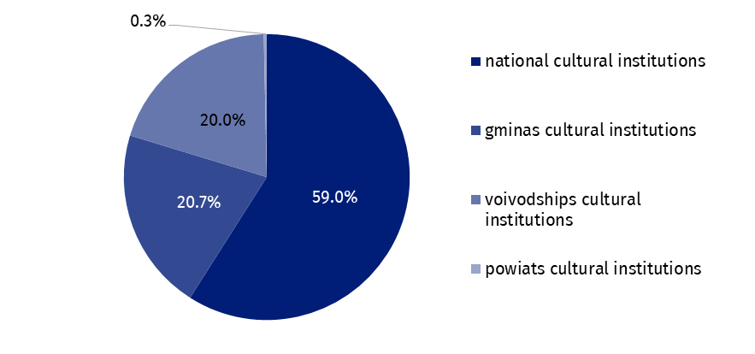
Chart 1. Investment outlays of cultural institutions by legal forms in the first quarter of 2024
In the first quarter of 2024 outlays of cultural institutions on intangible and legal assets decreased threefold compared to the corresponding period of the previous year and amounted to PLN 3.1 million. Almost 26% of the total outlays on intangible and legal assets were from Mazowieckie Voivodship.

Table 2. Total revenues and total costs of cultural institutions by selected divisions and classes of PKD classification in the first quarter of 2024
Specification | Number of cultural institutions | Total revenues | Total  costs
Specification | Number of cultural institutions | in PLN million
Grand total | 4,704 | 3,812.3 | 3,458.1
local government units property | 4,627 | 3,157.9 | 2,878.7
government property | 77 | 654.4 | 579.4
of which:
creative, arts and entertainment activities | 2,333 | 2,351.2 | 2,109.5
of which:
performing arts activities | 152 | 735.8 | 701.2
operation of arts facilities | 2,170 | 1,568.2 | 1,372.5
libraries, archives, museums and other cultural activities | 2,365 | 1,419.7 | 1,307.0
of which:
libraries and archives activities | 1,965 | 642.8 | 587.8
museums activities | 392 | 755.0 | 700.7
The data presented in this study were prepared on the basis of the form with the symbol
F-01/dk Quarterly report on the finances of cultural institutions.
In the case of quoting data from the Statistics Poland, please provide information: "Statistics Poland data source", and in the case of publishing calculations made on data published by the Statistics Poland, please provide information: "Own study based on Statistics Poland data".
Prepared by:  Statistical Office in Kraków  Director Agnieszka Szlubowska  Phone: (+48 12) 420 40 50 | Issued by:  Press Office  Mobile: (+48) 695 255 032  Phone: (+48 22) 608 38 04, (+48 22) 449 41 45,  (+48 22) 608 30 09  e-mail: obslugaprasowa@stat.gov.pl

stat.gov.pl/en/

@StatPoland

@GlownyUrzadStatystyczny

gus_stat

glownyurzadstatystycznygus

glownyurzadstatystyczny
Related information
Financial results of cultural institutions in 2023 – preliminary data
Methodological report. Non-financial enterprises surveys 2019
Terms used in official statistics
Total revenues
Total costs
Gross financial result
Net financial result
Investment outlays
Outlays on intangible fixed assets
Cultural institution

