Financial results of cultural institutions in the first half of 2024
In the first half of 2024, the financial results of cultural institutions increased compared to those obtained in the corresponding period of the previous year. Total revenues increased by 17.1% in this period, total costs increased by 16.8% and investment outlays decreased by 13.0% during this period.
17.1%
Total revenues increase y/y
Total revenues of cultural institutions in the first half of 2024 were 17.1% higher than those achieved a year earlier and amounted to PLN 7,937.4 million. In the structure of revenues, 92.4% were net revenues from the sale of products, goods and materials, 7.3% – other operating revenues, and 0.3% – financial revenues. Almost 25% of all revenues of cultural institutions were total revenues of entities located in Mazowieckie Voivodship.
On average total revenues per one cultural institution amounted to PLN 1,685.9 thousand. The highest total revenues per one institution were achieved by cultural institutions in Mazowieckie Voivodship – PLN 3,026.2 thousand and the lowest in Lubelskie Voivodship – PLN 807.3 thousand. Total revenues of local government cultural institutions amounted to PLN 6,540.0 million (82.4%), while total revenues of national cultural institutions amounted to PLN 1,397.5 million (17.6%). The largest share in total revenues of all cultural institutions had the entities operating arts facilities – 41.0%.
Total revenues of gminas local cultural institutions in the first half of 2024 amounted to PLN 4,573.0 million

Total costs during this period amounted to PLN 7,386.3 million and were 16.8% higher than those incurred a year earlier. In the structure of costs, 99.1% were operating costs, 0.8% – other operating costs, and 0.1% – financial costs. Over 24.0% of all costs were the total costs of cultural institutions from Mazowieckie Voivodship. In the total costs of cultural institutions the largest share had the costs of entities operating arts facilities – 40.2%.
Net financial result of cultural institution in the first half of 2024 amounted to PLN 550.1 million
Gross financial result amounted to PLN 551.1 million (gross profit PLN 618.9 million, gross loss PLN 67.9 million). Net financial result amounted to PLN 550.1 million (PLN 451.5 million in the previous year), with an increase in net profit (by 18.8%) and a decrease in net loss (by 1.1%).

Table 1. Financial results of cultural institutions
Specification | 01–06 2023 | 01–06 2024 | 01–06 2023=100
Specification | in PLN million |  | 01–06 2023=100
Total revenues | 6,775.8 | 7,937.4 | 117.1
Total costs | 6,323.4 | 7,386.3 | 116.8
Gross financial result | 452.4 | 551.1 | 121.8
Net financial result | 451.5 | 550.1 | 121.8
Net profit | 520.3 | 618.1 | 118.8
Net loss | 68.7 | 68.0 | 98.9
Investment outlays | 660.1 | 574.4 | 87.0
Outlays on intangible fixed assets | 19.2 | 7.5 | 39.3
In the first half of 2024 the investment outlays of cultural institutions amounted to PLN 574.4 million and were 13.0% lower than a year earlier. Almost 45% of all investment outlays of cultural institutions were total investment outlays of entities located in Mazowieckie Voivodeship.
Investment outlays incurred by national cultural institutions amounted to PLN 299.3 million, i.e. 52.1% of the total amount of investment outlays.

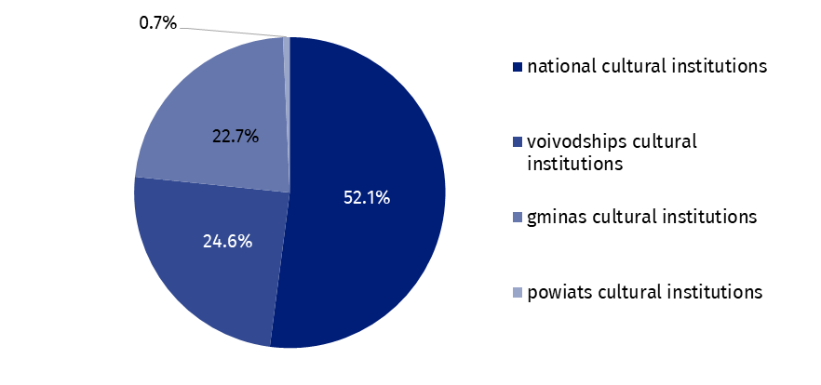
Chart 1. Investment outlays of cultural institutions by legal forms in the first half of 2024
In the first half of 2024 outlays of cultural institutions on intangible fixed assets decreased more than twice compared to the same period of the previous year and amounted to PLN 7.5 million. Over 28.0% of all outlays on intangible fixed assets came from Mazowieckie Voivodship.

Table 2. Total revenues and total costs of cultural institutions by selected divisions and classes of PKD classification in the first half of 2024
Specification | Number of cultural institutions | Total revenues | Total  costs
Specification | Number of cultural institutions | in PLN million
Grand total | 4,708 | 7,937.4 | 7,386.3
local government units property | 4,631 | 6,540.0 | 6,126.6
government property | 77 | 1,397.5 | 1,259.7
of which:
creative, arts and entertainment activities | 2,337 | 4,854.2 | 4,508.8
of which:
performing arts activities | 152 | 1,497.5 | 1,448.4
operation of arts facilities | 2,174 | 3,251.1 | 2,968.3
libraries, archives, museums and other cultural activities | 2,365 | 2,990.0 | 2,787.6
of which:
libraries and archives activities | 1,964 | 1,295.4 | 1,228.6
museums activities | 393 | 1,652.3 | 1,520.7
The data presented in this study were prepared on the basis of the form with the symbol
F-01/dk Quarterly report on the finances of cultural institutions.
In the case of quoting data from the Statistics Poland, please provide information: "Statistics Poland data source", and in the case of publishing calculations made on data published by the Statistics Poland, please provide information: "Own study based on Statistics Poland data".
Prepared by:  Statistical Office in Kraków  Director Agnieszka Szlubowska  Phone: (+48 12) 420 40 50 | Issued by:  Press Office  Mobile: (+48) 695 255 032  Phone: (+48 22) 608 38 04, (+48 22) 449 41 45,  (+48 22) 608 30 09  e-mail: obslugaprasowa@stat.gov.pl

stat.gov.pl/en/

@StatPoland

@GlownyUrzadStatystyczny

gus_stat

glownyurzadstatystycznygus

glownyurzadstatystyczny
Related information
Financial results of cultural institutions in the first quarter of 2024
Methodological report. Non-financial enterprises surveys 2019
Terms used in official statistics
Total revenues
Total costs
Gross financial result
Net financial result
Investment outlays
Outlays on intangible fixed assets
Cultural institution

