Financial results of cultural institutions in the period January–September 2024
The financial results of cultural institutions for the three quarters of 2024 were higher compared to those obtained in the same period of the previous year. Total revenues increased by 14.5% during this time, total costs increased by 14.6% and capital expenditures decreased by 5.3%.
14.5%
Total revenues increase y/y
Total revenues of cultural institutions for the first three quarters of 2024 were 14.5% higher than in the previous year and amounted to PLN 12,020.9 million. The structure of the revenues was composed of net revenues from sales of products, goods and materials (92.5%), other operating revenues (7.2%) and financial revenues (0.3%). Almost 25% of the total revenues were total revenues of cultural institutions from Mazowieckie Voivodship.
On average total revenues per one cultural institution amounted to PLN 2,554.9 thousand. The highest total revenues per one institution were achieved by cultural institutions in Mazowieckie Voivodship – PLN 4,565.5 thousand and the lowest in Lubelskie Voivodship – PLN 1,239.6 thousand. Total revenues of local government cultural institutions amounted to PLN 9,823.1 million (81.7%), while total revenues of national government cultural institutions amounted to PLN 2,197.8 million (18.3%). Entities conducting operation of arts facilities had the largest share in total revenues of all cultural institutions – 40.8%.
Total revenues of gminas’ cultural institutions for the first three quarters of 2024 amounted to PLN 6,885.2 million
Total costs of cultural institution during this period amounted to PLN 11,282.9 million and were 14.6% higher than in the previous year. The structure of costs was composed of operating costs (98.8%), other operating costs (1.2%) and financial costs (0.1%). More than 24% of the total costs were incurred by cultural institutions from Mazowieckie Voivodship. Entities conducting operation of arts facilities had the largest share in total costs – 40.7%.
Net financial result of cultural institution for the first three quarters of 2024 amounted to PLN 736.5 million
Gross financial result amounted to PLN 738.0 million (gross profit PLN 807.5 million, gross loss PLN 69.5 million). Net financial result amounted to PLN 736.5 million (PLN 643.5 million in the previous year), with an increase in net profit (by 13.9%) and an increase in net loss (by 8.8%).

Table 1. Financial results of cultural institutions
Specification | 01–09 2023 | 01–09 2024 | 01–09 2023=100
Specification | in PLN million |  | 01–09 2023=100
Total revenues | 10,494.3 | 12,020.9 | 114.5
Total costs | 9,849.4 | 11,282.9 | 114.6
Gross financial result | 644.8 | 738.0 | 114.5
Net financial result | 643.5 | 736.5 | 114.5
Net profit | 707.5 | 806.1 | 113.9
Net loss | 64.0 | 69.7 | 108.8
Investment outlays | 1,189.5 | 1,126.2 | 94.7
Outlays on intangible fixed assets | 30.7 | 15.4 | 50.0
In the first three quarters of 2024, investment outlays by cultural institutions amounted to PLN 1,126.2 million and were 5.3% lower than a year earlier. Over 48% of total investment outlays were total investment outlays of cultural institutions from Mazowieckie Voivodship.
Investment outlays incurred by local government cultural institutions amounted to PLN 642.7 million, i.e. 57.1% of the total amount of investment outlays.

Chart 1. Investment outlays of cultural institutions by legal forms for the first three quarters of 2024

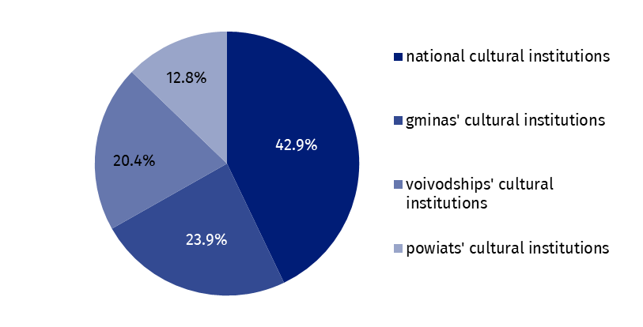
In the first three quarters of 2024 outlays of cultural institutions on intangible and legal assets decreased by half compared to the corresponding period of the previous year and amounted to PLN 15.4 million. Almost 34% of outlays on intangible and legal assets were from Mazowieckie Voivodship.

Table 2. Total revenues and total costs of cultural institutions by selected divisions and classes of PKD classification for the first three quarters of 2024
Specification | Number of cultural institutions | Total revenues | Total costs
Specification | Number of cultural institutions | in PLN million
Grand total | 4,705 | 12,020.9 | 11,282.9
local government units property | 4,629 | 9,823.1 | 9,317.3
government property | 76 | 2,197.8 | 1,965.6
of which:
creative, arts and entertainment activities | 2,337 | 7,210.3 | 6,828.0
of which:
performing arts activities | 152 | 2,178.2 | 2,111.0
operation of arts facilities | 2,176 | 4,905.4 | 4,597.2
libraries, archives, museums and other cultural activities | 2,362 | 4,662.1 | 4,311.4
of which:
libraries and archives activities | 1,962 | 1,988.5 | 1,878.5
museums activities | 392 | 2,622.0 | 2,387.0
In September 2024, some of the voivodships (Dolnośląskie, Lubulskie, Małopolskie, Opolskie and Śląskie) were affected by flood, which caused disastrous consequences for some towns. Of 1,347 cultural institutions, which are located in these five voivodships, 94 suffered negative effects of the flood, most of them (78.7%) only slightly. Serious consequences of the flood in September were experienced by 13 entities, and 7 entities - in the way that threatened the stability of institutions. The negative effects of the flood concerned mainly infrastructure, i.e. building with the associated area and equipment (64.9% of cultural institutions affected by flood), restrictions on running the activity (38.3%) and lack of visitors/people taking advantage of the institution’s offer (26.6%). Part of the institutions experienced large organisational problems in their functioning (11 institutions), destruction of collections (9), lack of employees (6) and problems with current financing (5).
The data presented in this study were prepared on the basis of the form with the symbol
F-01/dk Quarterly report on the finances of cultural institutions.
In the case of quoting data from the Statistics Poland, please provide information: "Statistics Poland data source", and in the case of publishing calculations made on data published by the Statistics Poland, please provide information: "Own study based on Statistics Poland data".

Prepared by:  Statistical Office in Kraków  Director Agnieszka Szlubowska  Phone: (+48 12) 420 40 50 | Issued by:  Press Office  Mobile: (+48) 695 255 032  Phone: (+48 22) 608 38 04, (+48 22) 449 41 45,  (+48 22) 608 30 09  e-mail: obslugaprasowa@stat.gov.pl

stat.gov.pl/en/

@StatPoland

@GlownyUrzadStatystyczny

gus_stat

glownyurzadstatystycznygus

glownyurzadstatystyczny
Related information
Financial results of cultural institutions in the first half of 2024
Methodological report. Non-financial enterprises surveys 2019
Terms used in official statistics
Total revenues
Total costs
Gross financial result
Net financial result
Investment outlays
Outlays on intangible fixed assets
Cultural institution

