Financial results of cultural institutions in 2024 – preliminary data
In 2024, the financial results of cultural institutions were higher in comparison to the previous year. Total revenues increased by 14.9% and total costs rose by 14.7%. Investment outlays were lower than in the previous year – by 9.2%.
14.9%
Total revenue increase y/y
Total revenues of cultural institutions in 2024 were higher by 14.9% than in the previous year and amounted to PLN 16,536.6 million. In the structure of revenues, 91.4% were net revenues from sale of products, goods and materials, 8.0% – other operating revenues and 0.6% – financial revenues. More than 25% of revenues were the total revenues of cultural institutions from Mazowieckie Voivodship.
Total revenues of gminas’ cultural institutions in 2024 amounted to PLN 9,285.2 million
Average total revenues per one cultural institution amounted to PLN 3,512.5 thousand. The highest total revenues per one institution were achieved by cultural institutions in Mazowieckie Voivodship – PLN 6,395.8 thousand, and the lowest in Lubelskie Voivodship – PLN 1,698.2 thousand. Local government cultural institutions achieved revenues of PLN 13,324.0 million (80.6%) and revenues of national government cultural institutions amounted to PLN 3,212.6 million (19.4%). In the total revenues of cultural institutions the largest share was held by entities operating arts facilities – 40.3%.
Total costs of cultural institiutions amounted to PLN 16,285.8 million and were higher by 14.7% than in the previous year. In the structure of costs, 98.4% were operating costs, 1.3% other operating costs and 0.3% financial costs. Over 25% of total costs were the costs of cultural institutions in Mazowieckie Voivodship. In the total costs of cultural institutions, the largest share was held by entities operating arts facilities – 40.5%.
Net financial result of cultural institutions in 2024 amounted to PLN 248.6 million
Gross financial result amounted to PLN 250.8 million (gross profit PLN 357.5 million, gross loss PLN 106.6 million). Net financial result amounted to PLN 248.6 million (PLN 196.6 million in the previous year), with an increase both in net profit (by 17.9%) and net loss (by 2.0%).

Table 1. Financial results of cultural institutions
Specification | 01–12 2023 | 01–12 2024
Specification | in PLN million |  | 01–12 2023=100
Total revenues | 14,396.8 | 16,536.6 | 114.9
Total costs | 14,198.2 | 16,285.8 | 114.7
Gross financial result | 198.6 | 250.8 | 126.3
Net financial result | 196.6 | 248.6 | 126.4
Net profit | 301.6 | 355.6 | 117.9
Net loss | 105.0 | 107.1 | 102.0
Investment outlays | 2,181.0 | 1,980.1 | 90.8
Outlays on intangible fixed assets | 51.9 | 34.8 | 67.1
In 2024 the investment outlays of cultural institutions amounted to PLN 1,980.1 million and were lower by 9.2% than in the previous year. Over 45% of total investment outlays were investment outlays of cultural institutions from Mazowieckie Voivodship.
Investment outlays of local government cultural institutions amounted to PLN 1,168.7 million, i.e. 59.0% of the total amount of investment outlays.

Chart 1. Investment outlays of cultural institutions by legal forms in 2024

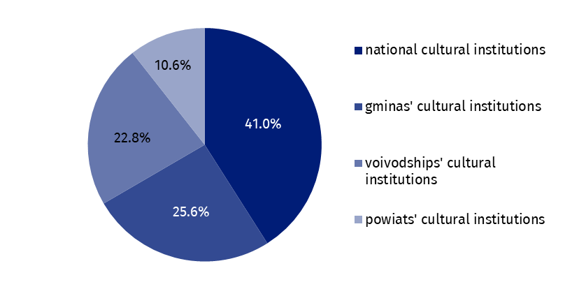
In 2024 outlays of cultural institutions on intangible fixed assets were lower in comparison to the previous year and amounted to PLN 34.8 million. Over 37% of total outlays on intangible fixed assets had cultural institutions from Mazowieckie Voivodship.

Table 2. Total revenues and total costs of cultural institutions by selected divisions and classes of PKD classification in 2024
Specification | Number of cultural institutions | Total revenues | Total costs
Specification | Number of cultural institutions | in PLN million
Grand total | 4,708 | 16,536.6 | 16,285.8
local government units property | 4,632 | 13,324.0 | 13,206.3
government property | 76 | 3,212.6 | 3,079.5
of which:
creative, arts and entertainment activities | 2,340 | 9,858.2 | 9,759.4
of which:
performing arts activities | 152 | 3,030.6 | 3,008.9
operation of arts facilities | 2,179 | 6,671.7 | 6,591.8
libraries, archives, museums and other cultural activities | 2,362 | 6,450.1 | 6,305.2
of which:
libraries and archives activities | 1,961 | 2,671.7 | 2,665.8
museums activities | 393 | 3,692.8 | 3,556.9
The data presented in this study were prepared on the basis of the form with the symbol F-01/dk Quarterly report on the finances of cultural institutions.
In the case of quoting data from the Statistics Poland, please provide information: “Statistics Poland data source”, and in the case of publishing calculations made on data published by the Statistics Poland, please provide information: “Own study based on Statistics Poland data”.
Prepared by:  Statistical Office in Kraków  Director Agnieszka Szlubowska  Phone: (+48 12) 420 40 50 | Issued by:  Press Office  Mobile: (+48) 695 255 032  Phone: (+48 22) 608 38 04, (+48 22) 449 41 45,  (+48 22) 608 30 09  e-mail: obslugaprasowa@stat.gov.pl

stat.gov.pl/en/

@StatPoland

@GlownyUrzadStatystyczny

gus_stat

glownyurzadstatystycznygus

glownyurzadstatystyczny
Related information
Financial results of cultural institutions in the period January-September 2024
Methodological report. Non-financial enterprises surveys 2019
Methodological report. Culture statistics
Terms used in official statistics
Total revenues
Total costs
Gross financial result
Net financial result
Investment outlays
Outlays on intangible fixed assets
Cultural institution

